IBM ASSIGNMENT-1 VISUALIZING THE DATA-SET

SAKTHIVEL.K.R

960519205013

B.Tech-INFORMATION TECHNOLOGY

CAPE INSTITUTE OF TECHNOLOGY.

# IBM COGNOS ANALYTICS WITH WATSON

* R&D Spend by state.
* R&D spend colored by state sized by marketing spend.
* State by R&D spend colored by marketing spend.
* Marketing spend by R&D colored by R&D spend.
* Profit by R&D spend colored by R&D spend.
* R&D spend, profit, R&D spend
* summary

# R&D SPEND BY STATE

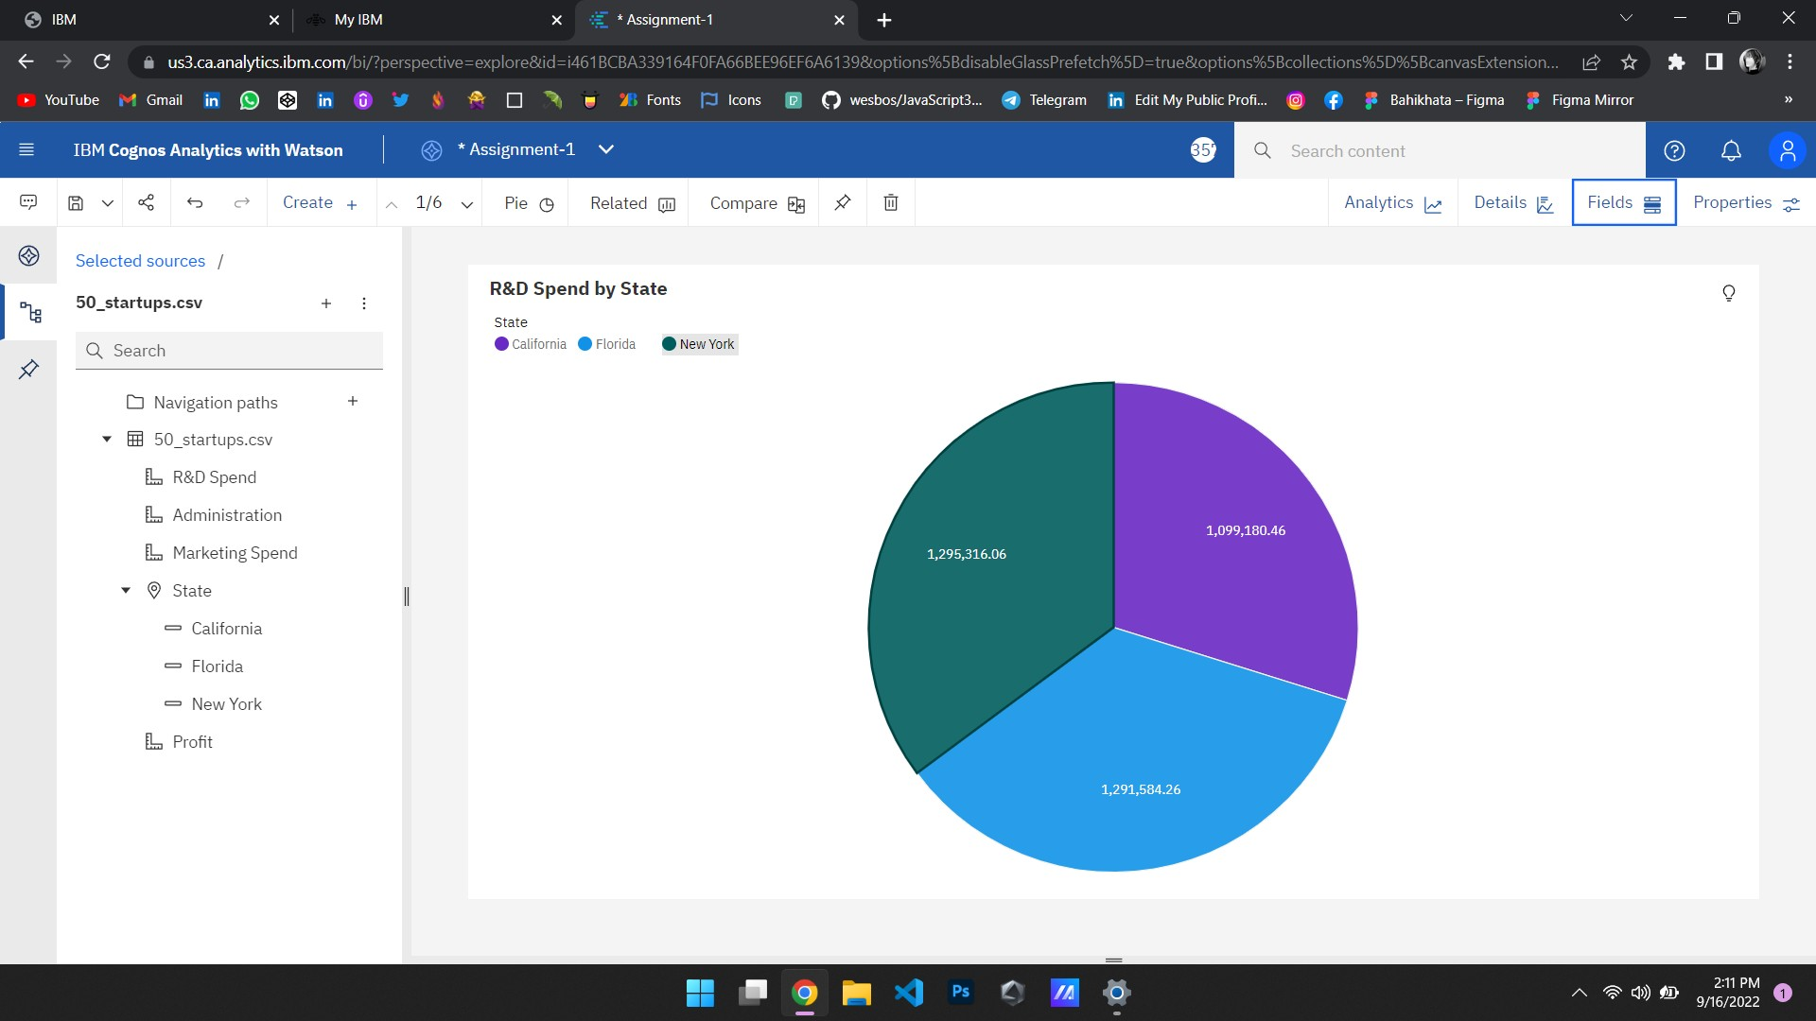

R&D SPEND COLORED BY STATE SIZED BY MARKETING SPEND

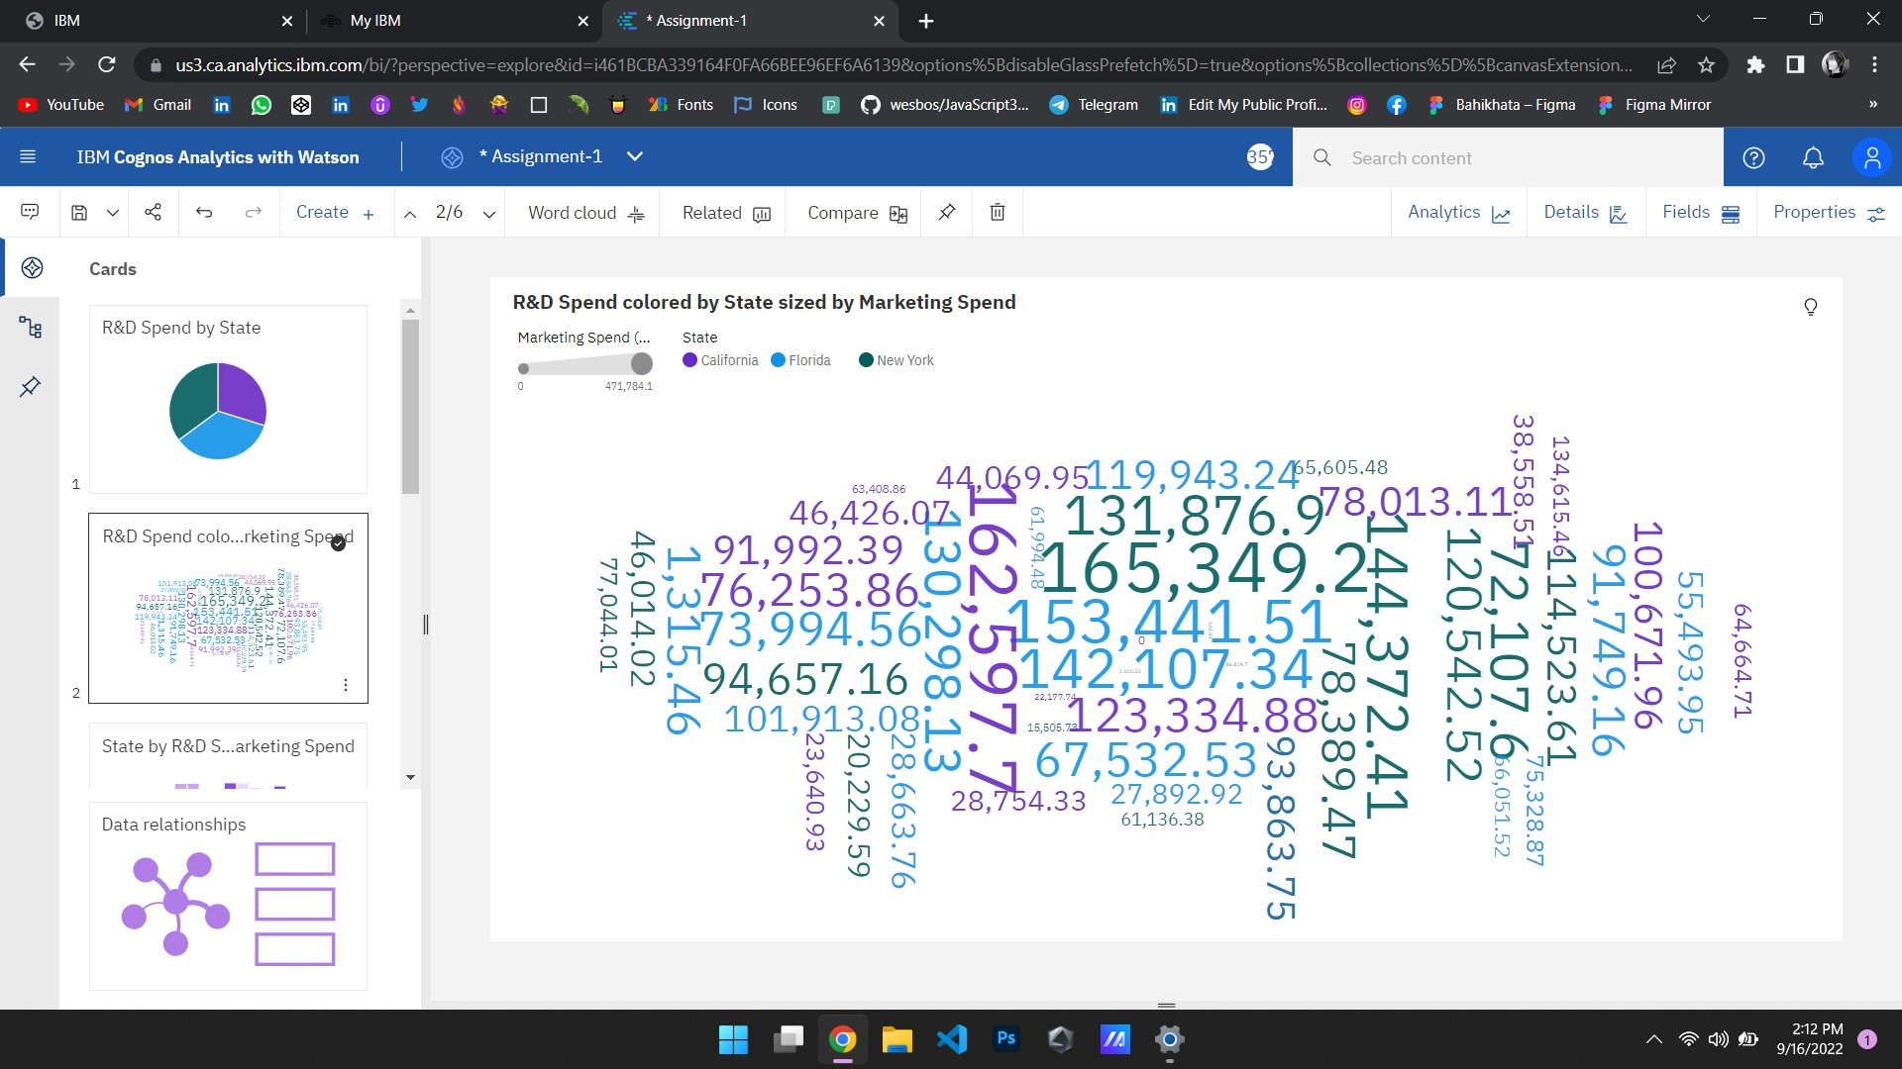

STATE BY R&D SPEND COLORED BY MARKETING SPEND

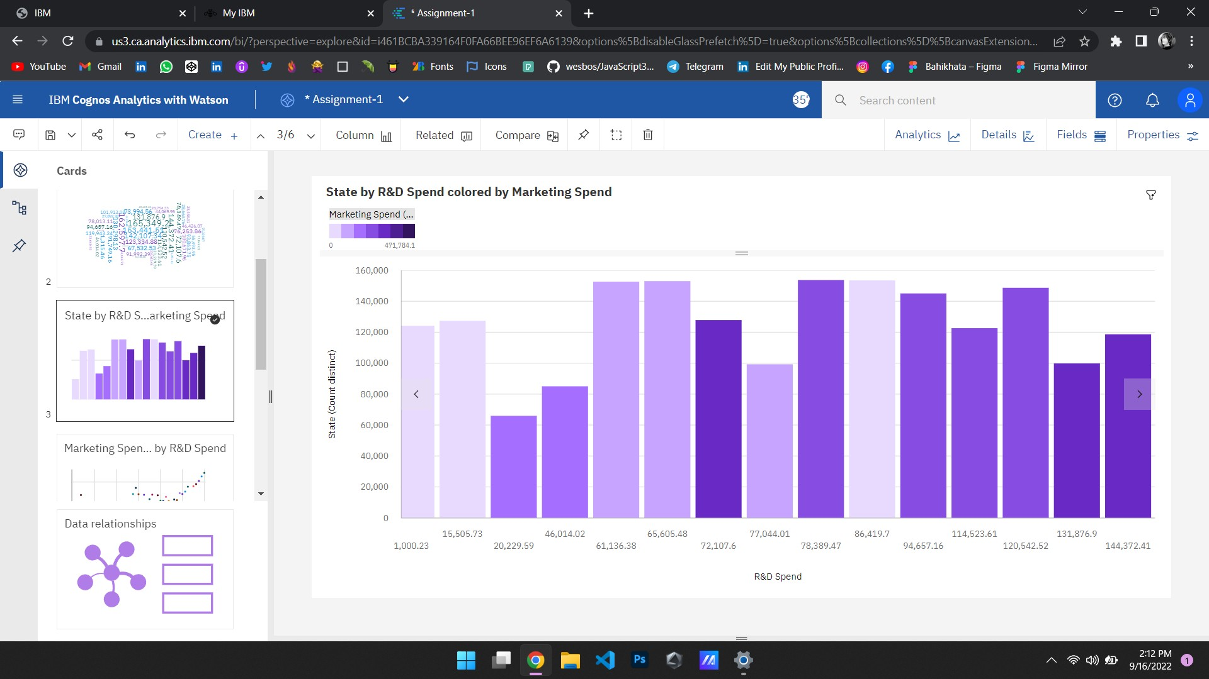

MARKETING SPEND BY R&D COLORED BY R&D SPEND

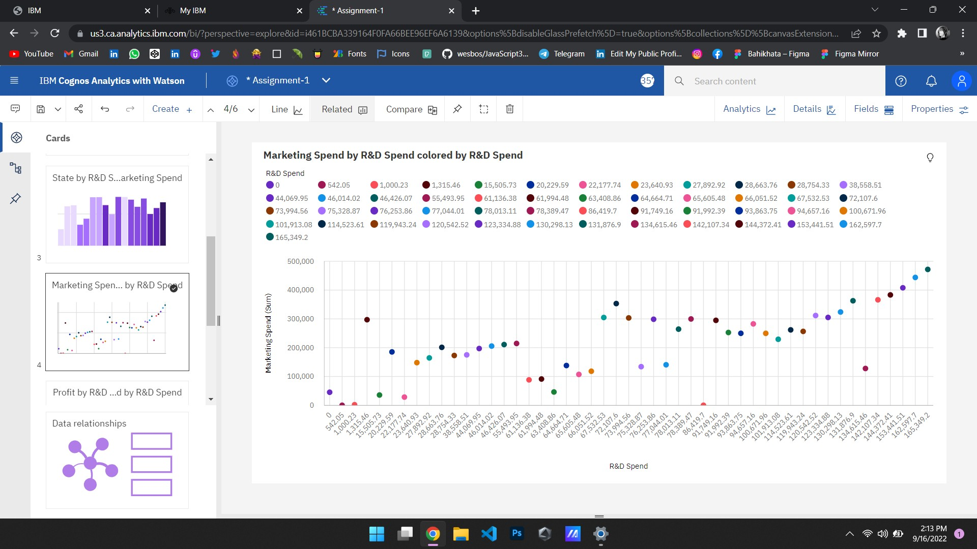

PROFIT BY R&D SPEND COLORED BY R&D SPEND

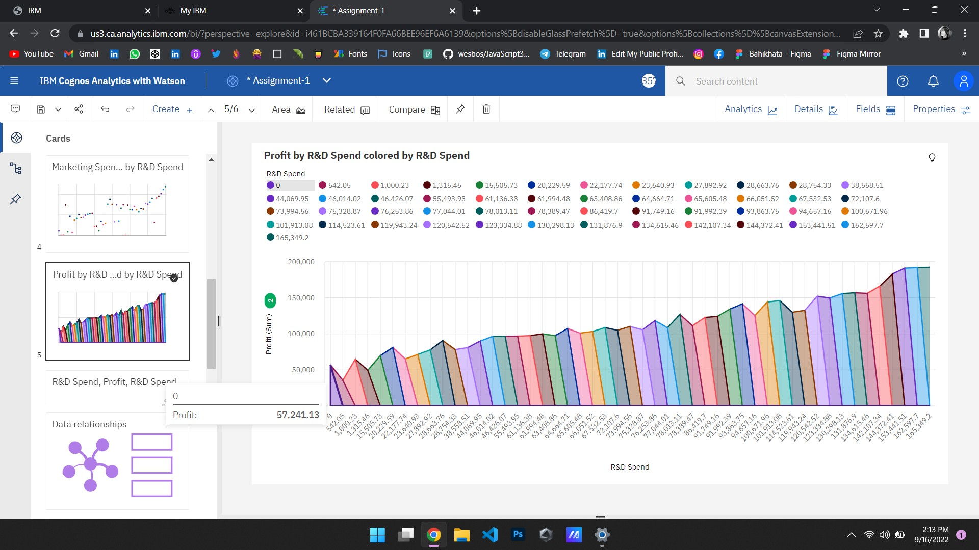

R&D SPEND, PROFIT, R&D SPEND

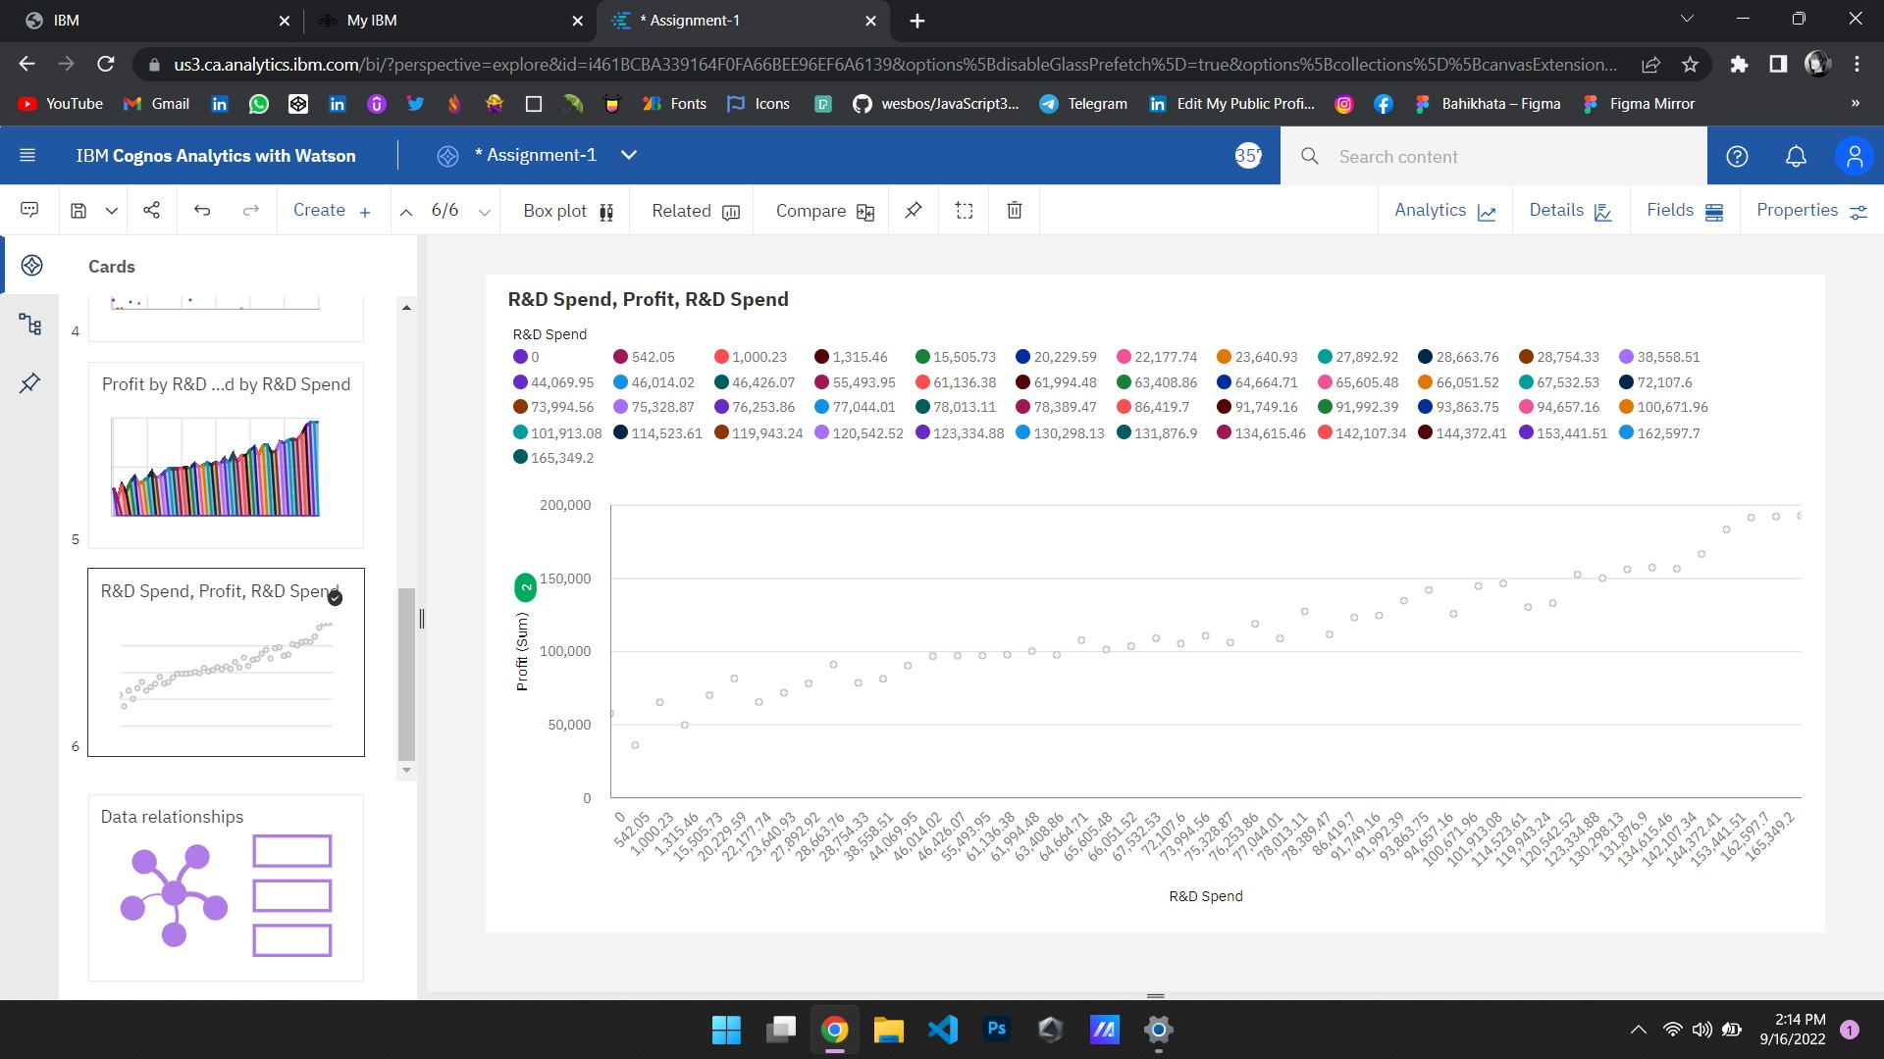

SUMMARY

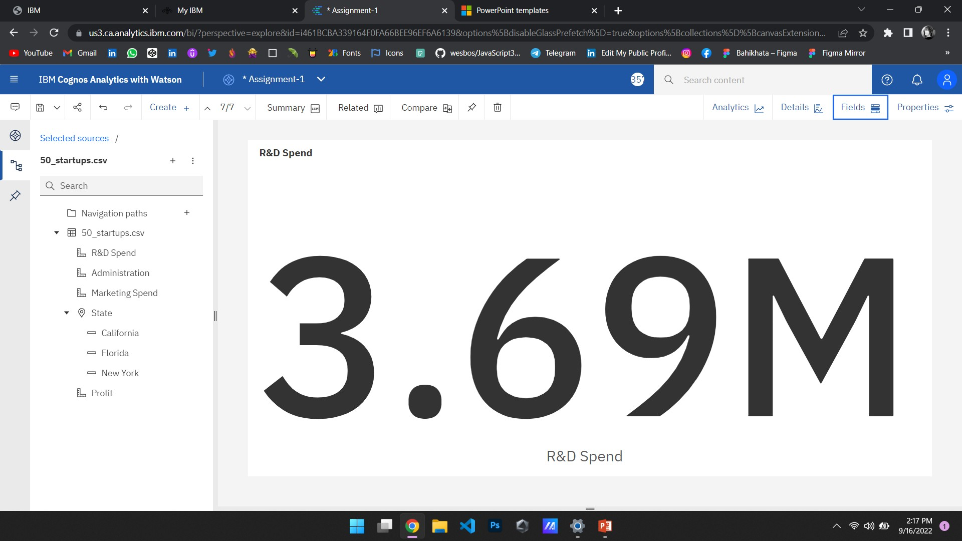

LINK TO OPEN MY DATA VISUALIZATION IN THE COGNOS ANALYTICS.

[https://us3.ca.analytics.ibm.com/bi/?perspective=explore&pathRef=.my_folders%2F Data%2BExploration%2FAssignment- 1&subView=model000001834565ecf6_00000004](https://us3.ca.analytics.ibm.com/bi/?perspective=explore&pathRef=.my_folders%2FData%2BExploration%2FAssignment-1&subView=model000001834565ecf6_00000004)